CHAPTER 18 Air Pollution
Core Case Study: South Asia’s Massive Brown cloud
- The Asian Brown Cloud covers India, Bangladesh, parts of China, and the open sea. What is in this brown cloud?

- Describe 2 negative effects the Asian Brown Cloud has had on life in these areas and other areas.

18-1: What Is the Nature of the Atmosphere?
The layers of the atmosphere are characterized by abrupt changes in __________________, differences in absorption of ____________ energy, _________________, and atmospheric _________________.

Air density and atmospheric pressure ________________ with altitude.

The Four Layers of the Atmosphere:
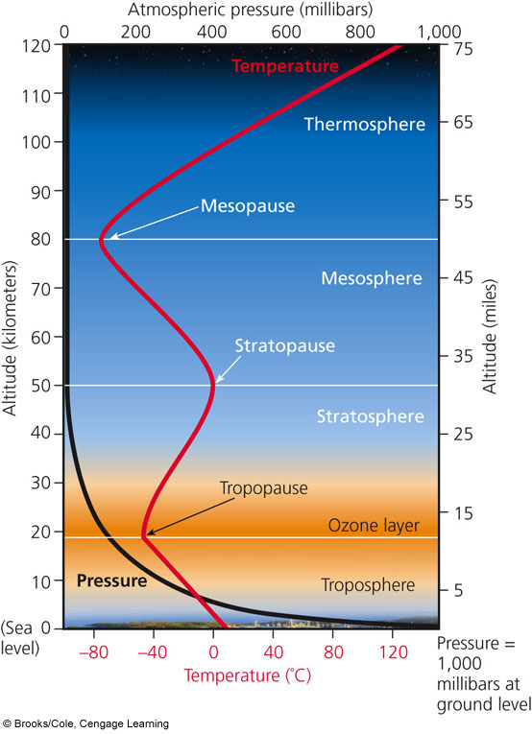
Stratosphere:
- Concentration of ozone (O3) is ____________ here called the _________ layer
- Describe how stratospheric ozone is produced:

- Why is ozone called the “global sunscreen?”

- Ozone in this layer of the atmosphere protects us from:

Troposphere:
- ______% of earth’s air mass
- Closest to the surface of earth
- Air we breathe is 78% ____ and 21% ____
- Air currents and wind cause ______________ and climate to happen in this layer

18-2: What Are the Major Outdoor Air Pollution Problems?
Air pollution is the presence of ____________________________________________________.

Natural Sources | Sources of Air Pollution | Human Sources
-dust blow from _________ and ______________ ______________  -_______________________ (VOCs) released by plants |  | -most are generated by burning ________________ in industrial plants (________________ source) and cars (_____________ source).
Case Study: Air Pollution in the Past- The Bad Old Days
Air pollution probably began when humans discovered __________ and were breathing in unhealthy smoke and soot.
The ________________ Revolution (late 1700’s) brought even worse air pollution when _________ was burned to power factories and heat homes. This brought an increase in cases of ___________________________________________.

History of Air Pollution in London-
1880: prolonged _________ fog killed 2,200 people in London.
1905: the word ________ was invented to describe the mixture of __________ and ________
1952: a dangerous yellow fog lasted ____ days and killed nearly _________ Londoners
*This tragedy prompted the _____________________________ of 1956.

History of Air Pollution in the US-
1948: ___________, Pennsylvania- pollution from coal burning factories, zinc smelter and a sulfuric acid plant became trapped in dense ________ that stagnated over the area for 5 days. 6,000 became ill and 20 died.

Primary Pollutants | Categories of Air Pollution | Secondary Pollutants
-harmful chemicals emitted ______________________________ from ____________ processes and human activity |  | -happens when ______________ pollutants ______________ with each other and form ______ harmful chemicals
If there are more factories and cars in urban areas, why do rural areas still have to deal with some primary and secondary pollutants? ___________________________________

Major Outdoor Air Pollutants
Name | Characteristics | Sources | Effects
Carbon Oxides | CO-  CO₂- | CO-  CO₂- | CO- reacts with _______________ in red blood cells and reduces blood’s ability to transport ________. Chronic exposure leads to asthma, emphysema, mental impairment, coma, death  CO₂- _______________ warming and climate change  Catalytic Converters-
Nitrogen Oxides and Nitric Acid | NO-  Nitric Acid- | NO-  Nitric Acid- | NO- ___________________ smog, can irritate _________________________, suppress ___________ growth  Nitric Acid- __________________ smog, acid ______________________
Sulfur Dioxides and Sulfuric Acid | SO₂-  Sulfuric acid- | SO₂-  Sulfuric acid- | Both SO₂ and Sulfuric Acid- acid ____________________, reduce ______________, aggravate _______________ problems, damage ________________________________, corrode _____________, and damage paint and __________ on buildings and statues.
Particulates |  |  | Fine and Ultrafine Particles-
Ozone |  |  | Ozone in the TROPOSPHERE:  Ozone in the STATOSPHERE:
Volatile Organic Compounds (VOCs) |  |  | Can cause _________________, ____________ disorders, dizziness, death
Case Study: Lead is a Highly Toxic Pollutant-
Lead (____) is a potent _________________ that does _______ break down in the environment.
Exposure causes _____________ system impairment, lowered _____, shortened attention span, etc.
Between 1976 and 2000, there has been a huge drop in lead poisoning cases because the government banned:

Some children are still being exposed because of:

Science Focus: Detecting Air Pollutants
One way to detect air pollutants is through a ______________ indicator- ___________
Lichen forms from a _______________ relationship between _________ and ________.
They are good indicators because they continually absorb _______.
Highly Polluted Area= ________________________ lichen or none at all
Moderate Air Pollution= _________________________ lichen
Clean Air Areas= _________ lichen on walls and trees
“Old Man’s Beard” Lichen and “Evernia” Lichen are sensitive to ___________________________.

Burning coal produces ________________________________:
-When coal and oil are burned: 1. Carbon is converted to ______ and ______
2. Sulfur reacts with O₂ to produce _______
3. Some of the SO₂ reacts with water vapor to produce ____________________
4. Some of the H₂SO₄ reacts with _______ to form solid ammonium sulfate
5. Unburned carbon goes into atmosphere is known as ___________
*All of these chemicals and particulates give smog the ___________ color.
-Today Industrial smog is less of problem in _______________ countries because of pollution control, such as smokestacks to blow pollution downwind to ___________ areas. It is still a problem in _________________ countries that still burn coal in houses and factories with inadequate pollution control. ____________ has highest levels of industrial smog.
______________________- mixture of primary and secondary pollutants under the influence of _______ radiation.

- Exhaust from car releases ______ & _______, and the NO is converted to a ______.
- _______________ causes a reaction between NO₂ and VOCs
- The resulting photochemical smog is a mixture of __________, nitric acid, aldehydes, PANs.
Collectively, these chemicals oxidize certain compounds in the atmosphere & your ___________!
*__________ days leads to higher levels of smog. *Cities in ___________________ climates with lots of cars have higher levels of smog. Ex: _________________________
DECREASE Air Pollution | Natural Factors That Influence Outdoor Air Pollution | INCREASE Air Pollution
1. Particles _________________ than air settle due to gravity  2. Rain and snow ____________ the air of pollutants  3. Salty sea spray from oceans wash out pollutants from air that flows over the ocean  4. __________ sweep pollutants away, diluting it with cleaner air  5. Some pollutants are removed by  ________________________________ |  | 1. Urban buildings can _______ wind speed and reduce dilution of pollutants  2. Hills and _________________ reduce flow of air in valleys so pollutants build up at ground level  3. High ____________________ promote photochemical smog  4. Emissions of _______ from certain trees and plants helps form photochemical smog  5. ____________________ Effect- air pollutants are transported by evaporation and winds to the _________ regions  6. Temperature ___________________ (see below)

TEMPERATURE INVERSION
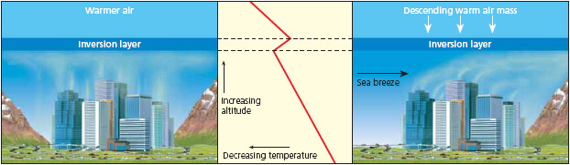
Cities that are built in ________ are subject to temperature inversions that can ________ pollutants over a city for days or weeks. This occurs when a layer of _________ air sits atop cooler _______________ air over a city and prevents the _______ air from rising and dispersing the pollutants. Cities with a sunny climate, light winds, and mountains on ____ sides (ex: ______________________) are also vulnerable.
18-3: What is Acid Deposition (aka ________________) and Why Is It a Problem?
Acid Deposition is the result of humans disrupting the _____ and _____ cycles.

________________________ are used to emit _____, particulates, and _____ high into the air where ___________ can mix, dilute, and disperse them. Reduce ______________ air pollution, but increases ______________ air pollution
- These ____________ substances remain in the air for days and can descend to the earth’s surface in 2 ways:
- _________ Deposition – acidic rain, snow, fog, cloud vapor with a pH <5.6
- _________ Deposition- acidic particles

Harmful Effects of Acid Deposition
- ____________________ disease
- damages statues, monuments, buildings, metals, car finishes
- decrease ___________________
- can _____________ toxic metals (lead and mercury) from soils and rocks into _____________ and
accumulates in the tissues of organisms (pregnant women shouldn’t eat fish for risk of mercury
contamination)
- makes some aquatic ecosystems too ___________- most fish can’t live below a pH of ______
- harm ________ if soil pH is below _______
- affects forests by leaching essential plant nutrients (______ and ______) from soils and releasing aluminum, lead, and mercury which are __________ to trees- weakens the trees; mountain top trees are the hardest hit

SOLUTIONS TO ACID DEPOSITION
Prevention | Clean Up
- Reduce _____________ use  - Increase use of renewable energy sources  - Remove SO₂ and NO from ______________ gases  - Remove NO from _______ exhaust  - _______ emissions of SO₂ | - Add lime to ________________________ acidified lakes  - Add __________________ fertilizer to neutralize acidified lakes
18-4: What Are the Major Indoor Air Pollution Problems?
Indoor Air Pollution:
- Biggest pollution threat to the _________ in ______________ countries
- caused by _________wood, charcoal, etc.in poorly ventilated areas
- ___________ Building Syndrome- buildings that have air pollutant counts high
enough to cause ____________ issues

Examples of Indoor Air Pollutants
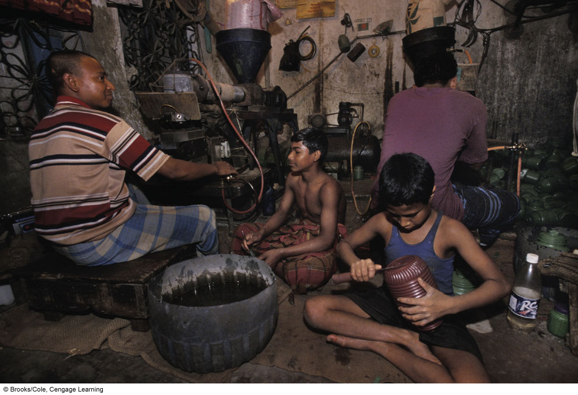
- Pesticides and lead brought in your ___________
- Living organisms and their excrements
- _______ mites , cockroach droppings
- Airborne spores of _________ and __________________
- ______________ smoke
- Formaldehyde- causes most difficulty in people in ______________ countries
- Radioactive _____________ gas
- Very fine _________________________
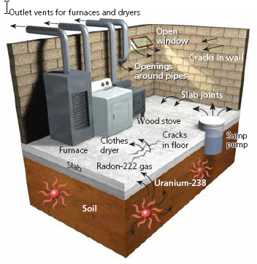

Case Study- Radioactive Radon Gas
- Produced by natural radioactive ____________ of ______________ in rocks and soils
- Enters a home through the ____________ in the foundation and walls
- Constant exposure can lead to ________ cancer
18-5: What Are the Health Effects of Air Pollution?
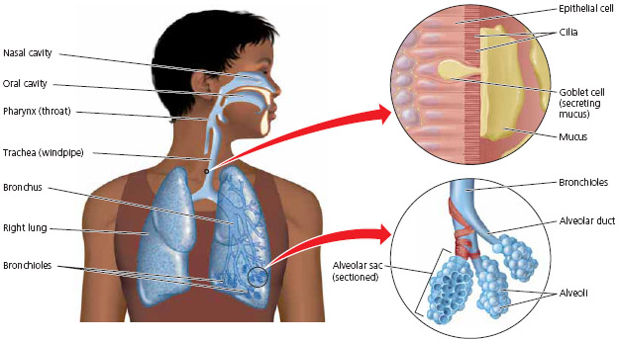
The _______________ System is a good line of defense against air pollution:
- _______ filters large particles
- ________ captures smaller particles
- _____________ and coughing expel air pollutants too
- small, hair-like ________
Prolonged exposure to air pollutants can overload or break down these natural defenses.
Fine and Ultrafine (most dangerous) _______________ get lodged deep in the __________ and contribute to lung cancer, asthma, and emphysema.
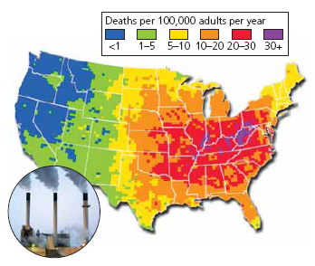

Air Pollution is a Big Killer:
- The World Health Organization (______) estimate
that ____ million people die each year due to the
effects of air pollution.
- 2.2 million of those deaths are due to ___________
air pollution.

18-6: How Should We Deal with Air Pollution?
EPA has established
*The 6 outdoor criteria air pollutants:
- ____________________________ 4. ___________________________
- ____________________________ 5. ___________________________
- ____________________________ 6. ___________________________
*Hazardous Air Pollutants (HAPS)- emissions standards
*Toxic Release Inventory (TRI)- factories, mines, refineries must report their release
of toxic chemicals

Congress has passed ______________________, but there is room for improvement:
- US relies mostly on pollution _______________, rather than __________________
- We have failed to increase _______________________ in cars
- Little regulation of oceangoing ships
- ________________ are exempt from regulations
- Laws don’t regulate emissions of __________
- ______________ particles are not regulated
- Does not deal with _______________ air pollution

Outdoor | Air Pollution Solutions | Indoor
- Emissions Trading (aka:  __________________________) allows major “polluters” to _________________________ emissions allotments to help reduce _______ emissions  - Burn low _____________ coal  - Disperse emissions above ________________________ layer with tall smokestacks.  - Use mass transit  - Give large _______ breaks for those who buy low polluting vehicles  - Inspect car ________________ throughout the year  - Rely more on ______________ energy sources  - Improve energy efficiency |  | - Ban _________________  - Stricter ___________________ emissions from carpet and furniture companies  - Use office machines in well _________________ areas  - Less polluting _____________ supplies  - Circulate buildings air through _____________ greenhouses  - Use exhaust hoods for stoves  - Prevent _______________ infiltration  - Distribute cheap, efficient stoves or solar cooker to _______________ countries  - Develop cheap _________ for indoor air pollutants  - ______ detectors
CHAPTER 19 Climate Change and Ozone Depletion

Core Case Study: Studying a Volcano to Understand Climate Change
- In 1991, Mount ______________ erupted, which allowed scientists to further study global ____________ change.
- Scientists studied that amount of ______ released by the volcano to determine if pollutants would indeed change the
climate of the Earth on a larger scale. It does.
19-1: How Might the Earth’s Temperature and Climate Change in the Future?
For the past 900,000 years the Earth has experienced period of global ______________ and global ______________. For the past 1,000 years the temperature has been _____________, but has begun to ___________ in the last century when people began ___________________
How are past temperatures determined?
- Radioisotopes in ________________________
- Bubbles of ancient _______ in ice cores
- Temperature taken at different depths in Earth
- Historical records
Life on Earth wouldn’t be possible without the natural _________________________________:
- _____________ the Earth’s lower atmosphere and surface due to greenhouse gasses like ___________________ that trap heat from the sun

The problem is when we have _____________ greenhouse gases and ____________ activities have led to this increase.
- Mainly due to agriculture, ____________________, and burning ________________
- At our current rate of emission of CO₂ we will have a concentration of ______ ppm by 2050, and according to research the __________ point is ______ ppm.
* Top 2 CO₂ emitting countries:
1. _______ (25%) 2. _______ (5%)
- Data from _______ cores also shows that 60% of _____________ emissions is due to ______________ activity from extracting fossil fuels, ______________, and livestock.
- Nitrous Oxide levels have also increased due to use of Nitrogen ____________________.

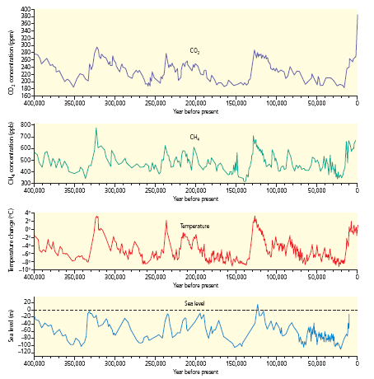

Evidence that Supports Climate Change: | Evidence For and Against Climate Change | Arguments Against Climate Change:
- Between 1906-2000, average global surface temp has increased by _________
- Greenhouse gas emissions has risen ____% since 1970
- _________ temps have risen twice as fast in the past 50 years
- _____________ are and floating sea ice are melting
- Rainfall patterns are changing
- Sea level has risen by _______ inches

What Role Does the Ocean Play?
- Oceans absorb _______ of all of the ______ released and help moderate temperature
- Some Carbon is _____________ salts that are buried in the sediments for millions of years
- __________________ of CO₂ decreases with ______________ temperature
- As water heats, the CO₂ could be ___________________ and amplify global warming= _________________ feedback loop
- Higher levels of CO₂ increases the ___________ of the ocean, which decreases the ability of ____________ to make calcium carbonate shells
**Bottom Line: Temperature, acidity, and ability to absorb CO₂ from atmosphere are changing as a result of human activities
19-2: What are Some Possible Effects of a Warmer Atmosphere?
Sea Levels are Rising:
Ice and Snow are Melting:
Browning of the Earth:

Extreme Weather:
Ocean Currents Changing:
Permafrost is Likely to Melt:

Health:
Agriculture:
Threat to Biodiversity:

19-3: What Can We Do to Slow Climate Change?
Why this complex problem is difficult to tackle:
- The problem is ____________________- much international cooperation
- Effects of climate change will last a long time- CO₂ stays in atmosphere _________
- It is a long term ________________ issue.
- Impacts of climate change are not spread ____________ across the globe.
- Phasing out changing our lifestyles would disrupt ________________ and lifestyles.

Solutions: Three Major Prevention Strategies-
- Improve energy ________________ to reduce fossil fuel use.
- Shift from nonrenewable _____ based fossil fuels to a mix of Carbon ________ renewable energy resources.
- Stop cutting down tropical ___________________.
** Effectiveness of these strategies would be enhanced by reducing ________________ and reducing _____________________.
Output Strategies for Reducing Climate Change:
1. Massive ______ planting on degraded land in the tropics.
2. Plant fast growing perennial plants like switchgrass- stores CO₂ in _______ to be harvested for _______________.
3. Carbon Capture & Storage (CCS)- removing
CO₂ from _______________ and pumping it deep into ____________ or abandoned oil or gas fields
-CCS is expensive and could raise prices
-require large inputs of ____________ to operate= counterproductive
-earthquakes, war, etc could cause a
________; even a small leak would be disastrous
Random Suggestions:
- Inject sulfate particles into ___________ -reflects __________ to cool troposphere
- “Re-ice” the ___________
- Deep sea ________ to bring up nutrients for algal blooms which can take in _____
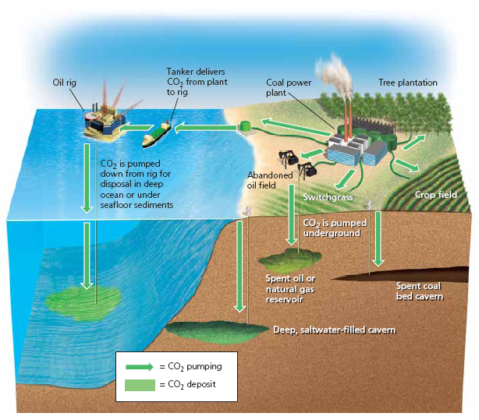

19-4: How Have We Depleted Ozone in the Stratosphere and What Can We Do About It?
What Can the Government Do to Slow Climate Change?

- Strictly regulate _______ and ______ pollutants.
- Carbon __________
- ____________________ Approach
- _______________ to businesses who use green technologies
- Technology transfer to _______________ countries
*__________________ Protocol- a treaty to slow climate change (2005)
-requires countries to cut emissions of ________________ by 5.2%
of their 1990 levels by 2012.
-countries can ___________ greenhouse gas emissions- the “cap and trade” system
-174 countries agreed to this. The US __________.
*George W. Bush decided not to comply because he felt it would harm the ______________ and he did not like how rapidly developing countries (like _____________) were exempt.
Who’s been successful?
- __________________ aims to be the first carbon __________ country. They currently generate 78% of their electricity from renewable _____________________ power and 18% from _____________ and ________________ energy!
- Some US States are tired of waiting on the federal government to take charge.
  - Portland, Oregon- 1st city to cut greenhouse gas emissions back to ____ levels.

    - The city promotes energy efficient ___________ and use of electricity from __________ and _________ sources.
    - Has built many bicycle trails & has greatly expanded ________________.
    - This has actually produced an economic _________ and has saved the city $_____________/year in energy costs!
  - California- 12th largest producer of greenhouse gases (GHG) in the world!
    - 2006- CA passed a law to cut GHG to _____ below 1990 levels by 2020.
    - Set fuel efficiency and carbon emissions standards and let the free market find the best ways to meet standards- EPA refused this request. CA and 17 other states are now suing the federal government to allow states to set tougher CO₂ emission standards.
  - Companies and Schools are reducing their Carbon Footprints
    - DuPont, IBM, Toyota, & Walmart have cut GHG emissions
What Can You Do to Reduce Your CO₂ emissions? Pick 3
- ______________________________________________________________________
- ______________________________________________________________________
- ______________________________________________________________________
Preparing for the Harmful Effects of Climate Change:
Global climate models say we must make a _________% cut in GHG emissions by 2050 so prevent Earth from heating up more than 3.6°F, which will likely be difficult to do. Therefore, analysts have compiled a list of things we need to do to prepare for the long-term effects of climate change. See Picture.

19-4: How Have We Depleted Ozone in the Stratosphere and What Can We Do about It?

Not only is there considerable thinning of the ozone in thepolar regions, but there is overall thinning everywhere as well.
Ozone depletion in the ________________ poses a serious threat to _______________, animals, and ________________.
Chlorofluorocarbons (CFCs)
*Discovered in _________ and use expanded rapidly
*Trade name = _____________
*Thought to be the dream chemical because it is chemically unreactive, _________________, nontoxic, _______________, and __________________
*Became popular as ______________ in ACs, refrigerators, cleaners for electric parts, propellant in spray cans, etc.
*Too good to be true: 1974- “CFCs destroy ___________ in stratosphere” said Rowland and Molina
-CFCs rise and remain in atmosphere
-Once CFCs reach atmosphere, it breaks
down under the influence of the ______
which releases a highly reactive ______
which break O₃ into O₂ and O
-CFCs persist in atmosphere for _________
years
-It took Rowland and Molina 14 years to
convince DuPont to stop production

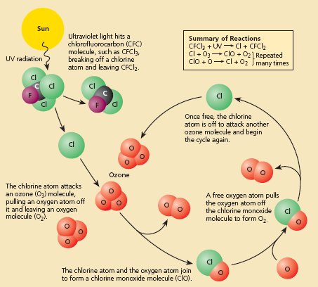

Why Should We Worry about Ozone Depletion?
- More damaging ______ and _____
radiation reaches the Earth’s surface.
- Sunburns, skin _____________
- Destroy ____________________- they play a key role in removing _____ and are
the base of ocean food web
How Can We Reverse Stratospheric Ozone Depletion?
- Stop use of all _______________________ chemicals
- Montreal Protocol- treaty’s goal is to cut _________ emissions by 35%

